**Static Web Design Using HTML**

**LAB # 03**



**Spring 2022**

**CSE403L Database Management Science**

Submitted by: **Ashfaq Ahmad**

Registration No: **19PWCSE1795**

Class Section: **B**

Student Signature: ______________

Submitted to:

**Ma’am Naina Said**

May 6, 2022

**Department of Computer Systems Engineering**

**University of Engineering and Technology, Peshawar**

Write the HTML code that generates the table given in Figure 3.10 (hint: use align attribute for cell alignment and set table width to 400 pixels

# SOURCE CODE

<!DOCTYPE html>

<html lang="en">

<head>

<meta charset="UTF-8">

<meta http-equiv="X-UA-Compatible" content="IE=edge">

<meta name="viewport" content="width=device-width, initial-scale=1.0">

<title>Document</title>

</head>

<body>

<h1>Tables</h1>

<table width="400px">

<tr style="background-color: #247881; color: #fff;">

<td width="100px">Ranks</td>

<td width="500px">Country</td>

<td width="100px">US $</td>

<td width="100px">Year</td>

</tr>

<tr>

<td>1</td>

<td>

<table>

<tr>

<td><img src="https://cdn.britannica.com/46/3346-004-D3BDE016/flag-symbolism-

Pakistan-design-Islamic.jpg"

alt="" width="25px" height="20px"></td>

<td style="color: #00AFC1;">Qatar</td>

</tr>

</table>

</td>

<td>133.454</td>

<td>2011</td>

</tr>

<tr>

<td>1</td>

<td>

<table>

<tr>

<td><img src="https://cdn.britannica.com/46/3346-004-D3BDE016/flag-symbolism- Pakistan-design-Islamic.jpg"

alt="" width="25px" height="20px"></td>

<td style="color: #00AFC1;">Qatar</td>

</tr>

</table>

</td>

<td>133.454</td>

<td>2011</td>

</tr>

<tr>

<td>1</td>

<td>

<table>

<tr>

<td><img src="https://cdn.britannica.com/46/3346-004-D3BDE016/flag-symbolism- Pakistan-design-Islamic.jpg"

alt="" width="25px" height="20px"></td>

<td style="color: #00AFC1;">Qatar</td>

</tr>

</table>

</td>

<td>133.454</td>

<td>2011</td>

</tr>

<tr>

<td>1</td>

<td>

<table>

<tr>

<td><img src="https://cdn.britannica.com/46/3346-004-D3BDE016/flag-symbolism- Pakistan-design-Islamic.jpg"

alt="" width="25px" height="20px"></td>

<td style="color: #00AFC1;">Qatar</td>

</tr>

</table>

</td>

<td>133.454</td>

<td>2011</td>

</tr>

<tr>

<td>1</td>

<td>

<table>

<tr>

<td><img src="https://cdn.britannica.com/46/3346-004-D3BDE016/flag-symbolism-

Pakistan-design-Islamic.jpg"

alt="" width="25px" height="20px"></td>

<td style="color: #00AFC1;">Qatar</td>

<tr>

</tr>

</table>

</td>

<td>133.454</td>

<td>2011</td>

</tr>

<tr>

<td>1</td>

<td>

<table>

<td><img src="https://cdn.britannica.com/46/3346-004-D3BDE016/flag-symbolism-

Pakistan-design-Islamic.jpg"

alt="" width="25px" height="20px"></td>

<td style="color: #00AFC1;">Qatar</td>

</tr> </table> </td>

<td>133.454</td>

<td>2011</td>

</tr> <tr>

<td>1</td>

<td>

<table>

<tr>

<td><img src="https://cdn.britannica.com/46/3346-004-D3BDE016/flag-symbolism-

Pakistan-design-Islamic.jpg"

alt="" width="25px" height="20px"></td>

<td style="color: #00AFC1;">Qatar</td>

</tr>

</table>

</td>

<td>133.454</td> <td>2011</td>

<tr>

</tr> <tr>

<td>1</td>

<td>

<table>

<td><img src="https://cdn.britannica.com/46/3346-004-D3BDE016/flag-symbolism-

Pakistan-design-Islamic.jpg"

alt="" width="25px" height="20px"></td>

<td style="color: #00AFC1;">Qatar</td>

</tr>

</table>

</td>

<td>133.454</td>

<td>2011</td>

</tr>

<tr>

<td>1</td>

<td>

<table>

<tr>

<td><img src="https://cdn.britannica.com/46/3346-004-D3BDE016/flag-symbolism-

Pakistan-design-Islamic.jpg"

alt="" width="25px" height="20px"></td>

<td style="color: #00AFC1;">Qatar</td>

</tr>

</table>

</td>

<td>133.454</td>

<td>2011</td>

</tr> <tr> <td>1</td> <td>

<table> <tr>

<td><img src="https://cdn.britannica.com/46/3346-004-D3BDE016/flag-symbolism- Pakistan-design-Islamic.jpg"

alt="" width="25px" height="20px"></td>

<td style="color: #00AFC1;">Qatar</td>

</tr> </table> </td>

<td>133.454</td> <td>2011</td> </tr>

</table>

</body>

</html>

# OUTPUT

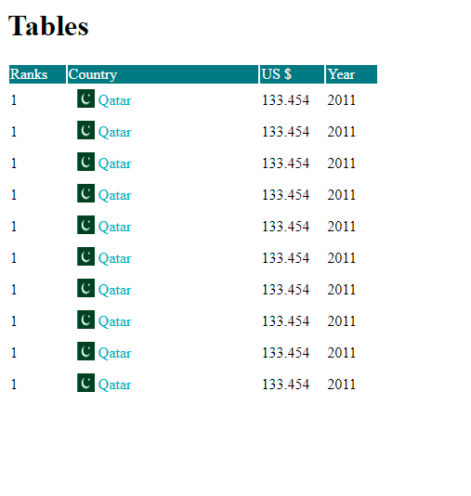

# TASK 3.2

**SOURCE CODE**

<!DOCTYPE html>

<html lang="en">

<head>

<meta charset="UTF-8">

<meta http-equiv="X-UA-Compatible" content="IE=edge">

<meta name="viewport" content="width=device-width, initial-scale=1.0">

<link href=["https](https://cdn.jsdelivr.net/npm/bootstrap%405.1.3/dist/css/bootstrap.min.css):[//cdn.jsdelivr.net/npm/bootstrap@5.1.3/dist/css/bootstrap.min.css"](https://cdn.jsdelivr.net/npm/bootstrap%405.1.3/dist/css/bootstrap.min.css) rel="stylesheet" integrity="sha384- 1BmE4kWBq78iYhFldvKuhfTAU6auU8tT94WrHftjDbrCEXSU1oBoqyl2QvZ6jIW3" crossorigin="anonymous">

<script src=["https:](https://cdn.jsdelivr.net/npm/bootstrap%405.1.3/dist/js/bootstrap.bundle.min.js)/[/cdn.jsdelivr.net/npm/bootstrap@5.1.3/dist/js/bootstrap.bundle.min.js"](https://cdn.jsdelivr.net/npm/bootstrap%405.1.3/dist/js/bootstrap.bundle.min.js) integrity="sha384-ka7Sk0Gln4gmtz2MlQnikT1wXgYsOg+OMhuP+IlRH9sENBO0LRn5q+8nbTov4+1p" crossorigin="anonymous"></script>

<script src=["https:](https://cdn.jsdelivr.net/npm/%40popperjs/core%402.10.2/dist/umd/popper.min.js)/[/cdn.jsdelivr.net/npm/@popperjs/core@2.10.2/dist/umd/popper.min.js"](https://cdn.jsdelivr.net/npm/%40popperjs/core%402.10.2/dist/umd/popper.min.js) integrity="sha384-7+zCNj/IqJ95wo16oMtfsKbZ9ccEh31eOz1HGyDuCQ6wgnyJNSYdrPa03rtR1zdB" crossorigin="anonymous"></script>

<script src=["https:](https://cdn.jsdelivr.net/npm/bootstrap%405.1.3/dist/js/bootstrap.min.js)/[/cdn.jsdelivr.net/npm/bootstrap@5.1.3/dist/js/bootstrap.min.js"](https://cdn.jsdelivr.net/npm/bootstrap%405.1.3/dist/js/bootstrap.min.js) integrity="sha384- QJHtvGhmr9XOIpI6YVutG+2QOK9T+ZnN4kzFN1RtK3zEFEIsxhlmWl5/YESvpZ13" crossorigin="anonymous"></script>

<title>INPUT FORM</title>

<link rel="stylesheet" href="./style.css">

</head>

<body>

<h1>Sign UP form</h1>

<div class="formDiv">

<form class="row g-3">

<div class="col-md-6">

<label for="Name" class="form-label">First Name</label>

<div>

<input type="email" class="form-control" id="inputEmail4" placeholder="First name">

</div>

</div>

<div class="col-md-6">

<label for="Name" class="form-label">Last Name</label>

<div>

<input type="email" class="form-control" id="inputEmail4" placeholder="Last name">

</div>

</div>

<div class="col-md-6">

<label for="inputEmail4" class="form-label">Email Address</label>

<input type="email" class="form-control" id="inputEmail4" placeholder=["na](mailto:name@gmail.com)m[e@gmail.com](mailto:name@gmail.com)">

</div>

<div class="col-md-6">

<label for="inputPassword4" class="form-label">Password</label>

<input type="password" class="form-control" id="inputPassword4">

</div>

<div class="col-md-6">

<button type="submit" class="btn btn-primary buttonClass">Register</button>

</div>

</form>

</div>

</body>

</html>

# CSS

body{

padding-left: 12rem; padding-right: 12rem; margin: 10rem 0;

background-color: #247881;

}

h1{

font-size: 2.5rem; justify-content: center; display: flex;

align-items: center; margin-bottom: 2rem; color: white;

}

.formDiv{

box-shadow: inset; border: 1px solid #43919B; padding: 2rem;

box-shadow: 0px 0px 10px 5px rgba(0, 0, 0, 0.75); border-radius: 15px;

background-color: #43919B;

}

.buttonClass{

background-color:#247881 ; border: 1px solid #247881;

}

.buttonClass:hover{ background-color:#247881 ; border: 1px solid #247881; transform: scale(1.01);

transition: all ease-in;

}

input[type=checkbox] {

background-color: #247881 !important;

}

label{

font-size:larger; font-weight:700;

padding-bottom: .5rem;

}

Form 1

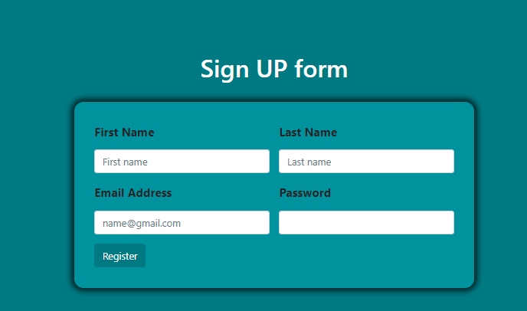

**SOURCE CODE**

<!DOCTYPE html>

<html lang="en">

<head>

<meta charset="UTF-8">

<meta http-equiv="X-UA-Compatible" content="IE=edge">

<meta name="viewport" content="width=device-width, initial-scale=1.0">

<link href=["https](https://cdn.jsdelivr.net/npm/bootstrap%405.1.3/dist/css/bootstrap.min.css):[//cdn.jsdelivr.net/npm/bootstrap@5.1.3/dist/css/bootstrap.min.css"](https://cdn.jsdelivr.net/npm/bootstrap%405.1.3/dist/css/bootstrap.min.css) rel="stylesheet" integrity="sha384- 1BmE4kWBq78iYhFldvKuhfTAU6auU8tT94WrHftjDbrCEXSU1oBoqyl2QvZ6jIW3" crossorigin="anonymous">

<script src=["https:](https://cdn.jsdelivr.net/npm/bootstrap%405.1.3/dist/js/bootstrap.bundle.min.js)/[/cdn.jsdelivr.net/npm/bootstrap@5.1.3/dist/js/bootstrap.bundle.min.js"](https://cdn.jsdelivr.net/npm/bootstrap%405.1.3/dist/js/bootstrap.bundle.min.js) integrity="sha384-ka7Sk0Gln4gmtz2MlQnikT1wXgYsOg+OMhuP+IlRH9sENBO0LRn5q+8nbTov4+1p" crossorigin="anonymous"></script>

<script src=["https:](https://cdn.jsdelivr.net/npm/%40popperjs/core%402.10.2/dist/umd/popper.min.js)/[/cdn.jsdelivr.net/npm/@popperjs/core@2.10.2/dist/umd/popper.min.js"](https://cdn.jsdelivr.net/npm/%40popperjs/core%402.10.2/dist/umd/popper.min.js) integrity="sha384-7+zCNj/IqJ95wo16oMtfsKbZ9ccEh31eOz1HGyDuCQ6wgnyJNSYdrPa03rtR1zdB" crossorigin="anonymous"></script>

<script src=["https:](https://cdn.jsdelivr.net/npm/bootstrap%405.1.3/dist/js/bootstrap.min.js)/[/cdn.jsdelivr.net/npm/bootstrap@5.1.3/dist/js/bootstrap.min.js"](https://cdn.jsdelivr.net/npm/bootstrap%405.1.3/dist/js/bootstrap.min.js) integrity="sha384- QJHtvGhmr9XOIpI6YVutG+2QOK9T+ZnN4kzFN1RtK3zEFEIsxhlmWl5/YESvpZ13" crossorigin="anonymous"></script>

<title>INPUT FORM</title>

<link rel="stylesheet" href="./style.css">

</head>

<body>

<h1>Car Registeration Form</h1>

<div class="formDiv">

<form class="row g-3">

<div class="col-md-6">

<label for="Name" class="form-label">Name</label>

<div>

<input type="email" class="form-control" id="inputEmail4" placeholder="Full name">

</div>

</div>

<div class="col-md-6">

<label for="inputEmail4" class="form-label">Email Address</label>

<input type="email" class="form-control" id="inputEmail4" placeholder=["na](mailto:name@gmail.com)m[e@gmail.com](mailto:name@gmail.com)">

</div>

<div class="col-md-6">

<label for="inputPassword4" class="form-label">Password</label>

<input type="password" class="form-control" id="inputPassword4">

</div>

<div class="col-md-6">

<label for="inputEmail4" class="form-label"> Country</label>

<div>

<select class="form-select" id="floatingSelect" aria-label="Floating label select example" >

<option selected style="padding-bottom: 20px;">Select country</option>

<option value="saab">Lahore</option>

<option value="mercedes">Islamabade </option>

<option value="audi">Karachi</option>

</select>

</div>

</div>

<div class="col-md-6">

<label for="exampleFormControlInput1" class="form-label" >Color</label>

<br>

<div class="form-check form-check-inline">

<input class="form-check-input" type="radio" name="inlineRadioOptions" id="inlineRadio1" value="option1">

<label class="form-check-label" for="inlineRadio1">Red</label>

</div>

<div class="form-check form-check-inline">

<input class="form-check-input" type="radio" name="inlineRadioOptions" id="inlineRadio2" value="option2">

<label class="form-check-label" for="inlineRadio2">Gray</label>

</div>

<div class="form-check form-check-inline">

<input class="form-check-input" type="radio" name="inlineRadioOptions" id="inlineRadio3" value="option2">

<label class="form-check-label" for="inlineRadio2">Blue</label>

</div>

</div>

<div class="col-md-6">

<label for="exampleFormControlInput1" class="form-label">Model</label>

<br>

<div class="form-check form-check-inline">

<input class="form-check-input" type="radio" name="inlineRadioOptions" id="inlineRadio1" value="option1">

<label class="form-check-label" for="inlineRadio1">2022</label>

</div>

<div class="form-check form-check-inline">

<input class="form-check-input" type="radio" name="inlineRadioOptions" id="inlineRadio2" value="option2">

<label class="form-check-label" for="inlineRadio2">2021</label>

</div>

<div class="form-check form-check-inline">

<input class="form-check-input" type="radio" name="inlineRadioOptions" id="inlineRadio3" value="option2">

<label class="form-check-label" for="inlineRadio2">2020</label>

</div>

</div>

<div class="col-md-6">

<label for="exampleFormControlInput1" class="form-label">Address</label>

<br>

<textarea name="address" id="address" style="width: 100%;resize: none" rows="4"></textarea>

</div>

div class="col-md-6">

<label for="exampleFormControlInput1" class="form-label">Temporay Address</label>

<br>

<textarea name="address" id="address" style="width: 100%;resize: none" rows="4"></textarea>

</div>

<div class="col-md-6">

<button type="submit" class="btn btn-primary buttonClass">Register</button>

</div>

</form>

</div>

</body>

</html>

# CSS

body{

padding-left: 12rem; padding-right: 12rem; margin: 10rem 0; background-color: #916BBF;

}

h1{

font-size: 2.5rem;

justify-content: center; display: flex;

align-items: center; margin-bottom: 2rem;

}

.formDiv{

box-shadow: inset;

border: 1px solid #E8E1D9; padding: 2rem;

box-shadow: 0px 0px 10px 5px rgba(0, 0, 0, 0.75); border-radius: 15px;

background-color: #C996CC;

}

.buttonClass{

background-color:#916BBF ; border: 1px solid #916BBF;

}

.buttonClass:hover{ background-color:#8236CB ; border: 1px solid #916BBF; transform: scale(1.01); transition: all ease-in;

}

input[type=checkbox] {

background-color: #916BBF !important;

}

label{

font-size:larger; font-weight:700;

padding-bottom: .5rem;

}

# OUTPUT FORM 2

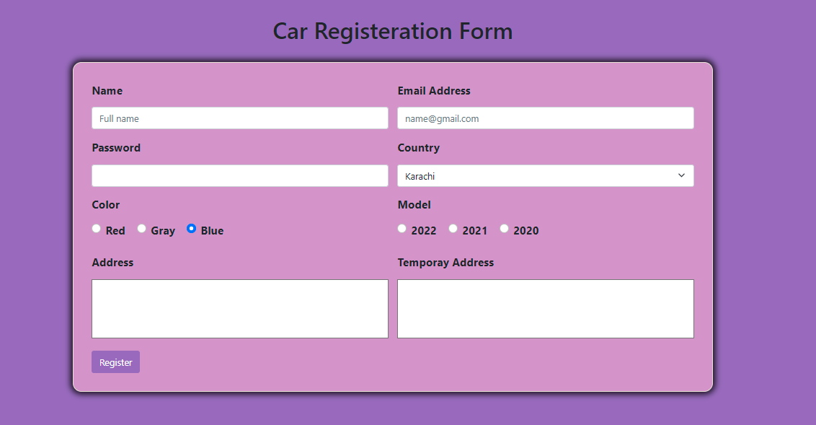

<!DOCTYPE html>

<html lang="en">

<head>

<meta charset="UTF-8">

<meta http-equiv="X-UA-Compatible" content="IE=edge">

<meta name="viewport" content="width=device-width, initial-scale=1.0">

<link href=["https](https://cdn.jsdelivr.net/npm/bootstrap%405.1.3/dist/css/bootstrap.min.css):[//cdn.jsdelivr.net/npm/bootstrap@5.1.3/dist/css/bootstrap.min.css"](https://cdn.jsdelivr.net/npm/bootstrap%405.1.3/dist/css/bootstrap.min.css) rel="stylesheet" integrity="sha384- 1BmE4kWBq78iYhFldvKuhfTAU6auU8tT94WrHftjDbrCEXSU1oBoqyl2QvZ6jIW3" crossorigin="anonymous">

<script src=["https:](https://cdn.jsdelivr.net/npm/bootstrap%405.1.3/dist/js/bootstrap.bundle.min.js)/[/cdn.jsdelivr.net/npm/bootstrap@5.1.3/dist/js/bootstrap.bundle.min.js"](https://cdn.jsdelivr.net/npm/bootstrap%405.1.3/dist/js/bootstrap.bundle.min.js) integrity="sha384-ka7Sk0Gln4gmtz2MlQnikT1wXgYsOg+OMhuP+IlRH9sENBO0LRn5q+8nbTov4+1p" crossorigin="anonymous"></script>

<script src=["https:](https://cdn.jsdelivr.net/npm/%40popperjs/core%402.10.2/dist/umd/popper.min.js)/[/cdn.jsdelivr.net/npm/@popperjs/core@2.10.2/dist/umd/popper.min.js"](https://cdn.jsdelivr.net/npm/%40popperjs/core%402.10.2/dist/umd/popper.min.js) integrity="sha384-7+zCNj/IqJ95wo16oMtfsKbZ9ccEh31eOz1HGyDuCQ6wgnyJNSYdrPa03rtR1zdB"

crossorigin="anonymous"></script>

# OUTPUT FORM 3

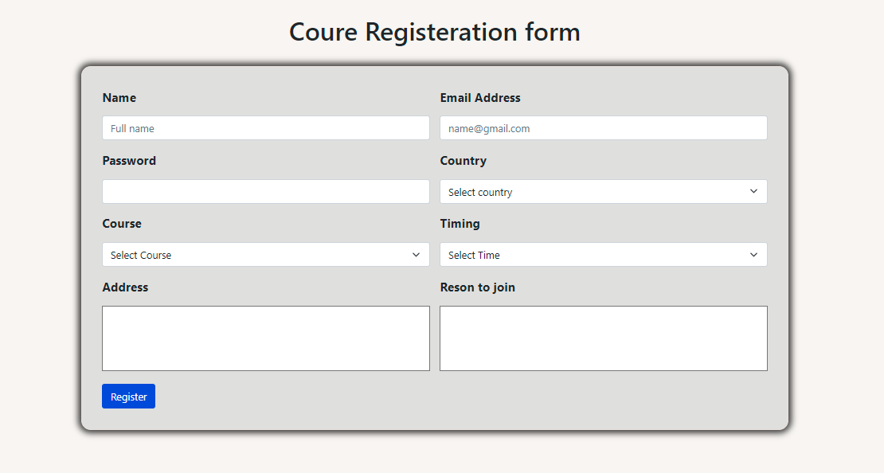

**Task 3.3 SVG**

Svg stands for scalable vector graphics. It is used to draw graphics in web. For example

# Code

<!DOCTYPE html>

<html lang="en">

<head>

<meta charset="UTF-8">

<meta http-equiv="X-UA-Compatible" content="IE=edge">

<meta name="viewport" content="width=device-width, initial-scale=1.0">

<title>Document</title>

</head>

<body>

<svg width="300" height="200">

<polygon points="100,10 40,198 190,78 10,78 160,198"

style="fill:rgb(1, 83, 17);stroke:rgb(27, 17, 27);stroke-width:5;fill-rule:evenodd;" />

</svg>

</body>

</html>



# Canvas

Canvas is used to draw graphics on a weeb page. A canvas is a rectangular area on an HTML page. By default, a canvas has no border and no content.

<!DOCTYPE html>

<html>

<body>

<canvas id="myCanvas" width="200" height="100" style="border:1px solid #000000;"> Your browser does not support the HTML canvas tag.

</canvas>

</body>

</html>

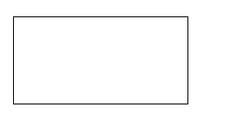

# Audio tag:

The <audio> tag is used to embed sound content in a document, such as music or other audio streams. Audio tag has different attributes like autoplay to start playing as soon as it is ready

Other attributes are control, loop etc

<!DOCTYPE html>

<html>

<body>

<h1>The audio element</h1>

<p>Click on the play button to play a sound:</p>

<audio controls>

<source src="music.ogg" type="audio/ogg">

<source src="music.mp3" type="audio/mpeg"> Your browser does not support the audio element.

</audio>

</body>

</html>



# Header:

Header tag usually contain navigation links in web page.

# SOURCE CODE

<!DOCTYPE html>

<html>

<body>

<header>

<h1>Header Example</h1>

<p>Loerm ibsum sdeak </p>

</header>

</body>

</html>

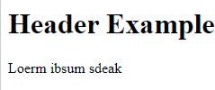

# Footer:

Footer tag is used in footer section of a document It usually contain

Authorship informantion Contact informantion etc



# Task 3.3 SOURCE CODE

<!DOCTYPE html>

<html lang="en">

<head>

<meta charset="UTF-8">

<meta http-equiv="X-UA-Compatible" content="IE=edge">

<meta name="viewport" content="width=device-width, initial-scale=1.0">

<title>Document</title>

</head>

<body style="margin-left: auto;margin-right: auto; width: 100%;">

<div style="display: flex; justify-content: center; align-items: center;">

<h1 style="align-items: c;">Cirruculum Vitae</h1>

</div>

<div style="display: flex; justify-content: center; align-items: center;">

<img src="./avatar"

alt="" style="border-radius:50%; margin-bottom: 3rem;">

</div

<div style="display: flex; justify-content: center; align-items: center;">

<table width="80%" cellpadding="10" cellspacing="10" border="1" bgcolor="#F2F2F2" frame="void" bg>

<tr>

<td>

<h2>About Me</h2>

Lorem ipsum dolor sit amet aLorem ipsum dolor sit amete

creating websites. I willing <br> <br>

Lorem ipsum dolor sit amet aLorem ipsum dolor sit amete creating websites. I willing

ons ctetur <br> <br> adipisng elit, seledr labore reliut dolore

labore reliut dolore

</td>

<td>

<div>

<table>

<h2>Personal Info </h2>

<tr>

<td>Phone</td>

<td>(+92) 333 5266782</td>

</tr>

<tr>

<td>Email</td>

<td>[abdulmajid1m2@gmail.com](mailto:abdulmajid1m2@gmail.com)</td>

<tr>

<td>Address</td>

<td>Safder Road Mansehra Pakistan</td>

</tr>

<br>

<tr>

<td>Gender</td>

<td>Male | Date of Birth . 28 Dec 2001</td>

</tr>

</tr>

</table>

</div>

</td>

</tr>

<tr>

<td>

<h2>Education</h2>

Bachelor Of Computer Systems Engineering

<br>

<br>

2019 - 2023 | Universi ty of Engineering And Technology Peshawar .

<br>

<br>

Intermediate (Pre-Engineering Group)

<br>

<br>

2017 - 2019 | Jinnah Basic School And College Mansehra.

<br>

<br>

Secondary School Certificate (Science Group)

<br>

<br>

2015 - 2017 | Garden Public High School Mansehra.

<br>

</td>

<td>

<h2>Technica Skill </h2>

<b>Python</b>

<br>

<b>CSS</b>

<br>

<b>JAVASCRIPT</b>

<br>

<b>NodeJS</b>

<br>

<b>MONGDB</b>

<br>

<b>React</b>

</td>

</tr>

<tr>

<td>

<h2>Personal Skill </h2>

<b>Communication Skill</b>

<br>

<b>Teamwork</b>

<br>

<b>Management Skill</b>

</td>

<td>

<h2>Projects </h2>

<ul>

<li> Lorem ipsum dolor sit amet, cons

ctetur adipisng elit, seled do eiumod tempor incidnt

</li>

<li> Lorem ipsum dolor sit amet, cons

ctetur adipisng elit, seled do eiumod tempor incidnt

</li>

</ul>

</td>

</tr>

<tr>

<td>

<h2>Languages </h2>

<b>English</b> <br><b>URDU</b>

</td>

<td>

<h2>Reference </h2>

<b>XYZ | Lorem ipsum dolor sit amet </b>

<br>

<b>XYZ | Lorem ipsum dolor sit amet </b>

</td>

</tr>

</table>

</div>

</body>

</html>

# OUTPUT

